**A new rapid resazurin-based microdilution assay for antimicrobial susceptibility testing of *Neisseria gonorrhoeae***

**Sunniva Förster1,2,3,4*, Valentino Desilvestro5, Lucy Hathaway3, Nicola Low1, Christian Althaus1 and Magnus Unemo2**

*1Institute of Social and Preventive Medicine, University of Bern, Bern, Switzerland; 2WHO Collaborating Centre for Gonorrhoea and other STIs, Örebro University, Örebro, Sweden; 3Institute for Infectious Diseases, University of Bern, Bern, Switzerland; 4Graduate School for Cellular and Biomedical Sciences, University of Bern, Bern, Switzerland; 5World Trade Institute (WTI), University of Bern, Bern, Switzerland*

*Corresponding author. Institute of Social and Preventive Medicine, University of Bern, Finkelhubelweg 11, 3012, Bern, Switzerland. Tel.: xxxxxxx; Fax: xxxxxxx; E-mail: sunniva.foerster@ifik.unibe.ch

**Running title:** Microdilution susceptibility assay for gonococci

**Word count:** Synopsis: xxx words, Main text: xxxx words

**Objectives:** Rapid, cost-effective and objective methods for antimicrobial susceptibility testing of *Neisseria gonorrhoeae* would greatly enhance surveillance of antimicrobial resistance. Etest, disc diffusion or agar dilution methods are subjective, laborious for large-scale testing, and take 16-20 hours. We developed a rapid broth microdilution assay using resazurin (blue), which is converted to resorufin (pink fluorescence), to analyse dose-response curves for antimicrobials in gonococcal isolates.

**Methods:** The resazurin-based broth microdilution assay was established using the 2008 WHO gonococcal reference strains (n=8) and the antimicrobials ceftriaxone, cefixime, azithromycin, spectinomycin, ciprofloxacin, gentamicin, tetracycline, and penicillin G. An initial dataset including 84 blinded gonococcal strains was then used to develop a regression model for estimating the MIC after six hours incubation time. The assay was finally validated with 40 blinded gonococcal strains.

**Results:** Results were obtained in approximately 7.5 hours. The EC50 of the dose-response curves correlates linear with Etest MIC values (R2 = 0.87). Only one very major error was found for a resistant ceftriaxone strain misclassified as susceptible. Minor errors resulting from misclassifications of intermediary resistant strains were found for 3.8% of the samples. Major errors occurred for ceftriaxone (34%), cefixime (24%), azithromycin (4%) and tetracycline (2%). Overall the sensitivity of the assay was 97.13% (CI: 95.22-98.42) and the specificity 79.27 % (CI: 74.84-83.23).

**Conclusions:** A rapid, objective, high-throughput, quantitative and cost-effective broth microdilution assay was established for gonococci.For use in routine diagnostics without confirmatory testing, the specificity might remain suboptimal for ceftriaxone and cefixime. However, the assay could be an effective low-cost method to evaluate novel antimicrobials, for high throughput screenings, and expands the currently available methodologies for surveillance of antimicrobial resistance in gonococci.

**Keywords:** Gonorrhoea, antimicrobial resistance, resazurin, broth microdilution, minimum inhibitory concentration, dose-response curve

**Introduction**

*Neisseria gonorrhoeae* is a very fastidious bacterium that causes the sexually transmitted infection gonorrhoea. Gonorrhoea is a public health concern globally,1,2 and *N. gonorrhoeae* has developed resistance to all antimicrobials introduced for treatment.3 Accordingly, enhanced surveillance of antimicrobial susceptibility in *N. gonorrhoeae* is imperative globally.1 Ideally, this surveillance should be performed using methods determining the MICs of relevant antimicrobials. MIC-based (Tapsall, 2009 #201;Unemo, 2012 #172;Unemo, 2011 #173)methods are also valuable to directly inform treatment after laboratory results are available- and evaluate *in vitro* efficacy of novel antimicrobials.

Due to the lack of any appropriate broth medium, MIC-based susceptibility testing of *N. gonorrhoeae* has been limited to disk diffusion, Etest and agar dilution method (gold standard). Essential agreement with the agar dilution method is defined as ±1 doubling dilution and should ideally be above 90% for diagnostic purposes where the same resistance breakpoints are applied.4 Etest has shown excellent agreement with the agar dilution method in many settings.4–7 However, discordant results have been found particularly when different growth media were used.8 A multicentre study revealed that the overall agreement within a method was above 70% categorical agreement between Etest and agar dilution was ≥ 88% but was very poor for disk diffusion.9 Unfortunately, these methods are relatively slow (~24 hours), subjective, require expertise, and/or are expensive. Faster methods that allow results to be obtained on the same day have been developed in the past for other bacteria10,11, but are not available for *N. gonorrhoeae*.

For many bacterial species, broth microdilution is the reference method due to accuracy, low costs and high versatility.12,13 Several attempts have been made to develop a broth microdilution method also for *N. gonorrhoeae* but none of the developed methods have been particularly accurate and suitable for routine use.14–16 It is difficult to synchronize the growth of different *N. gonorrhoeae* strains and effects such as autolysis occur when the bacteria enter the stationary phase.17–19 Chemically defined Graver-Wade (GW) broth20 supports the growth of phylogenetically diverse auxotypes and clinical isolates and might be a suitable medium for susceptibility testing.21,22

Unfortunately, MIC values based on doubling dilution series are left, interval, or right censored discrete data which makes error statistics challenging.23 The potency of drugs in pharmacology is frequently measured with dose-response curves, as this allows the estimation of the effective concentration (EC) at a specified response level. Furthermore, EC values on a continuous scale take the variability of the data into account by calculating model based confidence intervals (CIs). In the field of toxicology the upper border of the confidence interval is defined as non-toxic, this benchmark dose approach (BMD) has largely replaced methods that rely on dense dose spacing because of its statistical superiority and reduction of animal use.24–27 Furthermore, the slope of the pharmacodynamic curve potentially provides additional valuable information on the compounds being tested.28 The Hill coefficient can potentially provide information about the pharmacodynamic properties of an antimicrobial and has been used in modelling studies of single and dual antimicrobial effects.21,22,42–44 However, the interpretation and significance of the Hill slope has been unclear in previous studies and laborious colony counting limited these studies to few strains. Theoretically a steep Hill slope indicates that small increases in antimicrobial concentrations result in more effective killing.

The biological response to a compound can be measured using different readouts. Traditionally the MIC is defined as the concentration of an antimicrobial that inhibits visual growth but methods to quantify the number of bacterial cells more objectively are available nowadays. Measuring the optical density (at e.g. OD600 or OD450), resazurin (Alamar blue), 3-(4,5-dimethyethiazol-2-yl)-2,5-diphenyltetrazolium bromide (MTT), luciferase (ATP levels) and lactate dehydrogenase are widespread methods where readouts indirectly correlate with the number of cells.29 Resazurin is a blue dye that is converted to pink fluorescent resorufin in the presence of metabolically active cells.30,31 Unlike optical density that is a measure of growth inhibition, it reflects the viability of cells and is potentially suitable for time-kill assays as well. Resazurin has an excellent signal to noise ratio and has been used previously in screenings for toxicity testing, high throughput applications and MIC testing.30,32

The aim of the present study was to develop a resazurin-based broth microdilution assay for antimicrobial susceptibility testing of *N. gonorrhoeae* that is rapid, objective, scalable, quantitative and inexpensive. Three datasets were generated in this study. A panel of reference strains (n=8) was studied to ensure the reproducibility of the assay and compare multiple measurement endpoints in a time-course between 0-15 hours. Training data consisting of 84 strains were used to develop a predictive model for estimating the MIC from dose-response curves. Finally, a panel of forty strains with blinded MICs was used to validate the prediction.

**Material and methods**

***Bacterial strains, culture and broth microdilution assay***

The resazurin assay was established using the 2008 WHO gonococcal reference strains (n=8)33,34 and the antimicrobials ceftriaxone, cefixime, azithromycin, spectinomycin, ciprofloxacin, gentamicin, tetracycline, and penicillin G. The shortest possible endpoint for measuring the MIC was determined by measuring the fluorescence of the reference panel strains during a time-course from 0-15 hoursThe reference panel of eight WHO strains was examined in three independent experiments with an endpoint of six hours to test the intra-assay coefficient of variation of the assay as previously described35. A training dataset of 84 blinded gonococcal strains was then used to develop a regression model for estimating the MIC after six hours incubation time (one replicate). The assay was finally validated with 40 blinded gonococcal strains (one replicate). The blinded strains were selected to represent a wide variety of antibiograms. The strains were preserved in glycerol stocks at -80°C. All strains were subsequently cultured on Chocolate agar PolyViteX (Biomerieux, Marcy l'Etoile, France) at 37°C in a humid 5% CO2-enrichedatmosphere for 16-18 hours and then sub-cultured once for 16 hours. A McFarland standard of 0.5 was prepared for each strain and 1 mL further diluted to approximately 1x107 CFU/mL in 15 mL heated (37°C) GW broth.20 A volume of 90 µL of this suspension was added to 96-well round bottom microtiter plates (360 μL wells) with each well containing 10 µL of a previously prepared dilution series. Dilution series of the antimicrobials were prepared in GW medium. Positive control (GW medium containing 1% TritonX-100) and negative control (10 µL GW medium) were added to the first and last well, respectively. The plates were incubated for 6 hours at 37°C, humid 5% CO2-enrichedatmosphere.

***Resazurin readouts***

Resazurin powder (Sigma Aldrich, China) was diluted in PBS (pH 7.4) to a final concentration of 0.1 mg/mL. It was ensured that the pH of the highest antimicrobial concentration was neutral in all samples to avoid artefacts. After incubation of the broth microdilution plates, 50 µL of the dye was added to each well and mixed using an electronic multichannel dispenser. The plates were incubated for 75 minutes at 37°C. Fluorescence was then measured at 560 and 590 nm excitation in a plate reader (Varioskan Flash, Thermo Scientific).

***Etest MIC***

The Etest MICs (bioMérieux) were determined in accordance with the manufacturer´s instructions, on GCRAP agar plates (3.6% Difco GC Medium Base agar [BD, Diagnostics, Sparks, MD, USA] supplemented with 1% haemoglobin [BD, Diagnostics] and 1% IsoVitalex [BD, Diagnostics]).

***Dose-response modelling***

The antimicrobial effect on the different bacterial strains was quantified with dose-response curves. Firstly background fluorescence resulting from dead bacteria in the positive control wells was subtracted. A sigmoidal model was fit to the viability data of each antimicrobial-strain combination36:

Four parameters describe the curve, the lower model asymptote *l*, the upper model asymptote *u*, the slope of the curve *H* and the *EC50* . The background resulting from dead bacteria (positive controls) was subtracted. Next, the data were divided by *u* to normalize all dose response curves to 100% viability. Pairwise t-test of the mean of the hill slopes for each of the tested antimicrobials were made to test if the differences found in this parameter are significant. Hierarchical complete linkage clustering of the hill slopes was used to compare the antimicrobials as previously described21.

The *EC50*was measured for each of the antimicrobial-strain combinations. Samples were considered to be above the limit of detection, and therefore categorized as resistant, if the antibiotic, at its highest concentration, reduced viability by less than 50%. This was the case for 6 samples in the training data (n=672), 9 samples in the validation data (n=320) and 3 reference strain samples (n=192). Excluding Etest MICs that were above or below limit of detection and samples where EUCAST resistance breakpoints are not available to date (gentamicin) resulted in 571 evaluable samples in the training data, 269 samples in the validation data and 137 in the reference strain data.

The relationship between *EC50* and Etest was analysed for the training data by log transforming both values and fitting a linear regression. Slope and intercept of this regression were used to predict the MIC from the *EC50* of all data.

Confidence intervals (CI) for the predicted MICs were calculated using bootstrapping. The model based standard error of the *EC50* values was used for resampling a normal distribution and drawing 105 *EC50* estimates. Subsequently a sample of 105 combinations of linear regression parameters was drawn from a two dimensional normal distribution, with the variance-covariance matrix of slope and intercept of the log-log regression. Solving the regression equation results and taking the 0.025 and 0.975 percentiles of this distribution results in 95% CIs. The analysis pipeline and raw data are available from github (xxxx).

Essential agreement was defined as the percentage of strains with predicted MICs that do not deviate more than ±1 doubling dilution from Etest MICs. Deviations from the Etest MICs were calculated as log2 differences from the predicted MIC (840 evaluable samples for training and validation data). Reference strain data were not included to avoid bias from replicate testing of these samples.

***Categorical agreement with Etest***

The strains were categorized as S (susceptible), I (intermediate), and R (resistant) to each antimicrobial in accordance with the EUCAST 2016 guidelines.37 As previously described,38 minor errors were defined as misclassifications of intermediate strains as susceptible or resistant. Major errors were susceptible strains misclassified as resistant. Very major errors were resistant strains that were misclassified as susceptible. The *EC50* values are read on a continuous scale, therefore nearly identical values around a resistance breakpoint (e.g. 0.125 and 0.126) can result in categorical errors. Sensitivity and specificity of the assay were calculated as previously described39, for the resistant (true positive samples), intermediary strains (true positive samples) and susceptible strains (true negative samples).

**Results**

***Dose-response modelling***

The 2008 WHO reference strains (n=8) were exposed to ceftriaxone, cefixime, azithromycin, spectinomycin, ciprofloxacin, gentamicin, tetracycline, and penicillin G for a time course from 0 to 15 hours (Figure S1). After six hours, the difference between dead and viable gonococcal cells was sufficiently pronounced to fit dose-response curves to the data. For this endpoint of six hours, the coefficient of variation was calculated for the *EC50* of three independent experiments. The coefficient of variation (CV) ranged from 1.7% to 100%, the intra-assay CV was 28% (n=64) (Figure S2). Dose-response curves were gradually shifted towards higher concentrations, indicating increased potency of the antimicrobials in the intermediary resistant and resistant strains compared to susceptible strains (Figure 1). There was a clear separation of susceptible and resistant strains for ciprofloxacin and spectinomycin. For the β-lactams ceftriaxone, cefixime and penicillin G the hill coefficients (slopes) were more heterogeneous than for the other samples. The mean of this parameter gradually increased from ceftriaxone (1.8) to cefixime (2), tetracycline (2.1), penicillin G (2.3), azithromycin (2.5), spectinomycin (2.9) and was highest for gentamicin (3.3) (Figure S3A). A pairwise *t*-test showed that the differences between the antimicrobials were significant (p-value <0.005) when the distance between the means was larger than 0.5 (Figure S3B). Furthermore, hierarchical clustering shows a high similarity of the hill coefficient for the β-lactams ceftriaxone, cefixime and penicillin G compared to the other antimicrobials. The correlation between the Etest MICs and *EC50* values for all antimicrobials was 0.87 (Figure 2A). Compared to the Etest values, the *EC50* values were systematically lower with a median deviation of -1.68 doubling dilutions (Figure 2B). Slope (1) and intercept (1.1) of the linear log-log regression were used to predict the 840 MICs of training and validation data. This prediction shifted the median deviation from Etest MICs to 0.004 doubling dilutions. The 75% percent quartiles for the deviations were larger for azithromycin, cefixime and ceftriaxone compared to ciprofloxacin, penicillin G, spectinomycin and tetracycline (Figure 1C). The essential agreement between the Etest MICs and the predicted MICs was 47% for all antimicrobials, being lowest for cefixime (29%) and highest for penicillin G (61%).

***Categorical agreement***

The Etest and predicted MICs were classified as susceptible, intermediate and resistant according to the EUCAST 2016 resistance breakpoints30 (Figure 3). According Etest MIC xx% of the samples were classified as resistant, xx% as intermediary resistant and xx% as resistant. For spectinomycin, tetracycline and penicillin G, no major errors were identified. False positive misclassifications (S to R), i.e. major errors, occurred for ceftriaxone (34%), cefixime (24%), azithromycin (4%), and tetracycline (2%). False negative misclassifications (R to S), i.e. very major errors, were very rare and only identified for one ceftriaxone sample (Etest MIC 0.19 mg/L vs. 0.053 mg/L). A high number of misclassifications (38 cases) was due to MIC values close to the breakpoints and had 95% CIs spanning two categories. Overall the sensitivity of the assay was 97.13% (CI: 95.22-98.42) and the specificity 79.27 % (CI: 74.84-83.23).

**Discussion**

The developed resazurin-based broth microdilution assay was able to discriminate between resistant and susceptible strains reliably in an assay time, considerably shorter (approximately 7.5 hours) than those of the currently available MIC methods for *N. gonorrhoeae*. The gold standard methods agar dilution and Etest are both based on subjective, visual readouts and are therefore limited to a relatively low throughput. Dose-response modelling allows the estimation of the *EC50* of antimicrobials from a continuous scale and therefore allows calculation of a precise estimates including confidence intervals rather than having the precision limited by doubling dilutions. Continuous values from dose-response curves are inherently difficult to compare to resistance breakpoints designed for doubling dilution-based methods. This was reflected by many categorical errors resulting from estimates that have CIs overlapping two SIR categories. The overall sensitivity including errors resulting from misclassified intermediary strains was 97.13% (CI: 95.22-98.42). The performance of the assay was excellent for ciprofloxacin, penicillin G and spectinomycin (no major errors) and acceptable for azithromycin (4% major errors) and tetracycline (2% major errors). For cefixime and ceftriaxone many false positive results and consequently an overestimation of resistance was measured. The complex mechanism of action of these antimicrobials is not well understood and involves several resistance determinants (*PenA*, *PenB*, *mtrR*, *ponA, factorX)*. The correlation of *EC50*and MIC has been previously shown to be largely influenced by different penicillin binding proteins in *Streptococcus pneumoniae*.40 This might explain the strain dependent heterogeneity of hill coefficients (Figure S3) and dose response curves that are biphasic (Figure S4).22,41 To model such complex effects is not possible with the simple four parameter hill function employed in this this study and therefore contributed to the poor specificity of only 79.27 % (95% CI: 74.84-83.23). The deviation from Etest follows a normal distribution, 95% of the values are within ± 4 doubling dilutions, outliers can be attributed to the β-lactams penicillin G (large overestimation in beta lactamase producing strains), cefixime and ceftriaxone (potentially biphasic or triphasic curves with large confidence intervals). The essential agreement was suboptimal and might reflect why it has been difficult to establish a broth microdilution assay for fastidious gonococci in the past. An endpoint of six hours provided only a snapshot of the antimicrobial properties and examining much more time-points, starting inocula, and very large number of strains might provide valuable data for improvements. Furthermore, obtaining significantly more data, possibly by scaling the assay to a robotic platform, would enable the regression analysis to be performed for the different antimicrobials separately and also allow fitting a biphasic model.

Despite these drawbacks, the developed rapid resazurin-based broth microdilution assay is highly objective (avoids visual subjective readout) and employs a standardized algorithm reducing operator bias, which can be especially valuable in multicentre studies. These properties, and the low price of resazurin, are especially valuable when screening large libraries of new compounds, antimicrobials or antimicrobial combinations. Frequently, the question that needs to be answered is the potency of antimicrobials relative to each other rather than absolute numbers. While pH stripes are excellent for distinguishing acid from basic chemicals, complex questions such as titration curves of a weak with a strong acid need more quantitative approaches.

Cefixime, ceftriaxone and penicillin G had significantly flatter slopes than the other antimicrobials.

In summary, the developed resazurin-based broth microdilution assay is a rapid, objective, high-thoughput, quantitative and cost-effective new tool for studying *N. gonorrhoeae* in liquid culture. The Hill coefficient could be compared for a large number of strains highlighting differences between antimicrobials. The new assay opens up avenues for high-throughput synergy testing, evaluation of novel antimicrobials and surveillance of resistance.

**Funding**

The present study was funded through an Interdisciplinary PhD (IPhD) project from SystemsX.ch (The Swiss Initiative for Systems Biology), RaDAR-Go (RApid Diagnosis of Antibiotic Resistance in Gonorrhoea; funded by the Swiss Platform for Translational Medicine), and the Örebro County Council Research Committee and the Foundation for Medical Research at Örebro University Hospital, Sweden.

**References**

1. WHO. Global action plan to control the spread and impact of antimicrobial resistance in Neisseria gonorrhoeae. 2012. Available at: http://apps.who.int/iris/bitstream/10665/44863/1/9789241503501_eng.pdf. Accessed December 6, 2016.

2. Newman L, Rowley J, Hoorn SV, *et al.* Global Estimates of the Prevalence and Incidence of Four Curable Sexually Transmitted Infections in 2012 Based on Systematic Review and Global Reporting. *PLOS ONE* 2015; **10**: e0143304.

3. Unemo M, Shafer WM. Antimicrobial Resistance in Neisseria gonorrhoeae in the 21st Century: Past, Evolution, and Future. *Clin Microbiol Rev* 2014; **27**: 587–613.

4. Biedenbach DJ, Jones RN. Comparative assessment of Etest for testing susceptibilities of Neisseria gonorrhoeae to penicillin, tetracycline, ceftriaxone, cefotaxime, and ciprofloxacin: investigation using 510(k) review criteria, recommended by the Food and Drug Administration. *J Clin Microbiol* 1996; **34**: 3214–7.

5. Liu H, Taylor TH, Pettus K et al. Assessment of Etest as an alternative to agar dilution for antimicrobial susceptibility testing of Neisseria gonorrhoeae. J Clin Microbiol 2014; 52: 1435–40.

6. Singh V, Bala M, Kakran M et al. Comparative assessment of CDS, CLSI disc diffusion and Etest techniques for antimicrobial susceptibility testing of Neisseria gonorrhoeae: a 6-year study. BMJ Open 2012; 2: e000969.

7. Gose S, Kong CJ, Lee Y et al. Comparison of Neisseria gonorrhoeae MICs obtained by Etest and agar dilution for ceftriaxone, cefpodoxime, cefixime and azithromycin. J Microbiol Methods 2013; 95: 379–80.

8. Liao C-H, Lai C-C, Hsu M-S et al. Antimicrobial susceptibility of Neisseria gonorrhoeae isolates determined by the agar dilution, disk diffusion and Etest methods: comparison of results using GC agar and chocolate agar. Int J Antimicrob Agents 2010; 35: 457–60.

9. Ison CA, Martin IMC, Lowndes CM et al. Comparability of laboratory diagnosis and antimicrobial susceptibility testing of Neisseria gonorrhoeae from reference laboratories in Western Europe. J Antimicrob Chemother 2006; 58: 580–6.

10. Kelly MT, Leicester C. Evaluation of the Autoscan Walkaway system for rapid identification and susceptibility testing of gram-negative bacilli. *J Clin Microbiol* 1992; **30**: 1568–71.

11. Godsey JH, Bascomb S, Bonnette T, *et al.* Rapid antimicrobial susceptibility testing of gram-negative bacilli using Baxter MicroScan rapid fluorogenic panels and autoSCAN-W/A. *Pathol Biol (Paris)* 1991; **39**: 461–5.

10. Reller LB, Weinstein M, Jorgensen JH et al. Antimicrobial susceptibility testing: a review of general principles and contemporary practices. Clin Infect Dis 2009; 49: 1749–55.

11. Wiegand I, Hilpert K, Hancock REW. Agar and broth dilution methods to determine the minimal inhibitory concentration (MIC) of antimicrobial substances. Nat Protoc 2008; 3: 163–75.

12. Takei M, Yamaguchi Y, Fukuda H et al. Cultivation of Neisseria gonorrhoeae in liquid media and determination of its in vitro susceptibilities to quinolones. J Clin Microbiol 2005; 43: 4321–7.

13. Geers TA, Donabedian AM. Comparison of broth microdilution and agar dilution for susceptibility testing of Neisseria gonorrhoeae. Antimicrob Agents Chemother 1989; 33: 233–4.

14. Shapiro MA, Heifetz CL, Sesnie JC. Comparison of microdilution and agar dilution procedures for testing antibiotic susceptibility of Neisseria gonorrhoeae. J Clin Microbiol 1984; 20: 828–30.

15. Dillard JP, Seifert HS. A peptidoglycan hydrolase similar to bacteriophage endolysins acts as an autolysin in Neisseria gonorrhoeae. Mol Microbiol 1997; 25: 893–901.

16. Elmros T, Burman LG, Bloom GD. Autolysis of Neisseria gonorrhoeae. J Bacteriol 1976; 126: 969–76.

17. Chan YA, Hackett KT, Dillard JP. The lytic transglycosylases of Neisseria gonorrhoeae. Microb Drug Resist 2012; 18: 271–9.

29. Wade JJ, Graver MA. A fully defined, clear and protein-free liquid medium permitting dense growth of Neisseria gonorrhoeae from very low inocula. FEMS Microbiol Lett 2007; 273: 35–7.

18. Foerster S, Golparian D, Jacobsson S et al. Genetic resistance determinants, in vitro time-kill curve analysis and pharmacodynamic functions for the novel topoisomerase II inhibitor ETX0914 (AZD0914) in Neisseria gonorrhoeae. Front Microbiol 2015; 6: 1377.

19. Foerster S, Unemo M, Hathaway LJ et al. Time-kill curve analysis and pharmacodynamic functions for in vitro evaluation of antimicrobials against Neisseria gonorrhoeae. BMC Microbiol 2016; 16: 216.

20. Kassteele J van de, Santen-Verheuvel MG van, Koedijk FDH et al. New statistical technique for analyzing MIC-based susceptibility data. Antimicrob Agents Chemother 2012; 56: 1557–63.

21. Slob W. Benchmark dose and the three Rs. Part I. Getting more information from the same number of animals. Crit Rev Toxicol 2014; 44: 557–67.

22. Slob W. Benchmark dose and the three Rs. Part II. Consequences for study design and animal use. Crit Rev Toxicol 2014; 44: 568–80.

23. Davis JA, Gift JS, Zhao QJ. Introduction to benchmark dose methods and U.S. EPA’s benchmark dose software (BMDS) version 2.1.1. Toxicol Appl Pharmacol 2011; 254: 181–91.

24. Filipsson AF, Sand S, Nilsson J et al. The benchmark dose method--review of available models, and recommendations for application in health risk assessment. Crit Rev Toxicol 2003; 33: 505–42.

25. Sampah MES, Shen L, Jilek BL et al. Dose–response curve slope is a missing dimension in the analysis of HIV-1 drug resistance. Proc Natl Acad Sci U S A 2011; 108: 7613–8.

26. Rampersad SN. Multiple applications of alamar blue as an indicator of metabolic function and cellular health in cell viability bioassays. Sensors 2012; 12: 12347–60.

27. Khalifa RA, Nasser MS, Gomaa AA et al. Resazurin microtiter assay plate method for detection of susceptibility of multidrug resistant Mycobacterium tuberculosis to second-line anti-tuberculous drugs. Egypt J Chest Dis Tuberc 2013; 62: 241–7.

28. Palomino J-C, Martin A, Camacho M et al. Resazurin microtiter assay plate: simple and inexpensive method for detection of drug resistance in Mycobacterium tuberculosis. Antimicrob Agents Chemother 2002; 46: 2720–2.

26. Schmitt DM, Connolly KL, Jerse AE et al. Antibacterial activity of resazurin-based compounds against Neisseria gonorrhoeae in vitro and in vivo. Int J Antimicrob Agents 2016; 48: 367–72.

33. Unemo M, Golparian D, Sánchez-Busó L, *et al.* The novel 2016 WHO Neisseria gonorrhoeae reference strains for global quality assurance of laboratory investigations: phenotypic, genetic and reference genome characterization. *J Antimicrob Chemother* 2016; **71**: 3096–108.

34. Unemo M, Fasth O, Fredlund H, Limnios A, Tapsall J. Phenotypic and genetic characterization of the 2008 WHO Neisseria gonorrhoeae reference strain panel intended for global quality assurance and quality control of gonococcal antimicrobial resistance surveillance for public health purposes. *J Antimicrob Chemother* 2009; **63**: 1142–51.

35. Schultheiss, O.C., Stanton, S.J. (2009). Assessment of salivary hormones. In: Harmon-Jones, E., Beer, J.S., eds. Methods in Social Neuroscience. New York: Guilford Press.

36. Anon. Bioassay Analysis Using R | Ritz | Journal of Statistical Software. Available at: https://www.jstatsoft.org/article/view/v012i05. Accessed March 16, 2016.

37. EUCAST. The European Committee on Antimicrobial Susceptibility Testing. Breakpoint tables for interpretation of MICs and zone diameters. 2016.

38. CLSI, Wayne, PA, USA. Clinical and Laboratory Standards Institute. Development of In Vitro Susceptibility Testing Criteria and Quality Control Parameters, 2nd edn. Approved Guideline M23-A2. 2001. Available at: http://shop.clsi.org/site/Sample_pdf/M23A3_sample.pdf. Accessed December 7, 2016.

39. Parikh R, Mathai A, Parikh S, Chandra Sekhar G, Thomas R. Understanding and using sensitivity, specificity and predictive values. *Indian J Ophthalmol* 2008; **56**: 45–50.

40. Kocaoglu O, Tsui H-CT, Winkler ME, Carlson EE. Profiling of β-Lactam Selectivity for Penicillin-Binding Proteins in Streptococcus pneumoniae D39. *Antimicrob Agents Chemother* 2015; **59**: 3548–55.

41. Di Veroli GY, Fornari C, Goldlust I, *et al.* An automated fitting procedure and software for dose-response curves with multiphasic features. *Sci Rep* 2015; **5**: 14701.

42. Regoes RR, Wiuff C, Zappala RM, Garner KN, Baquero F, Levin BR. Pharmacodynamic functions: a multiparameter approach to the design of antibiotic treatment regimens. *Antimicrob Agents Chemother* 2004; **48**: 3670–6.

43. Foucquier J, Guedj M. Analysis of drug combinations: current methodological landscape. *Pharmacol Res Perspect* 2015; **3**. Available at: http://www.ncbi.nlm.nih.gov/pmc/articles/PMC4492765/. Accessed November 17, 2015.

44. Yu G, Baeder DY, Regoes RR, Rolff J. Combination Effects of Antimicrobial Peptides. *Antimicrob Agents Chemother* 2016; **60**: 1717–24.

45. Schmitt DM, Connolly KL, Jerse AE, Detrick MS, Horzempa J. Antibacterial activity of resazurin-based compounds against Neisseria gonorrhoeae in vitro and in vivo. *Int J Antimicrob Agents* 2016; **48**: 367–72.

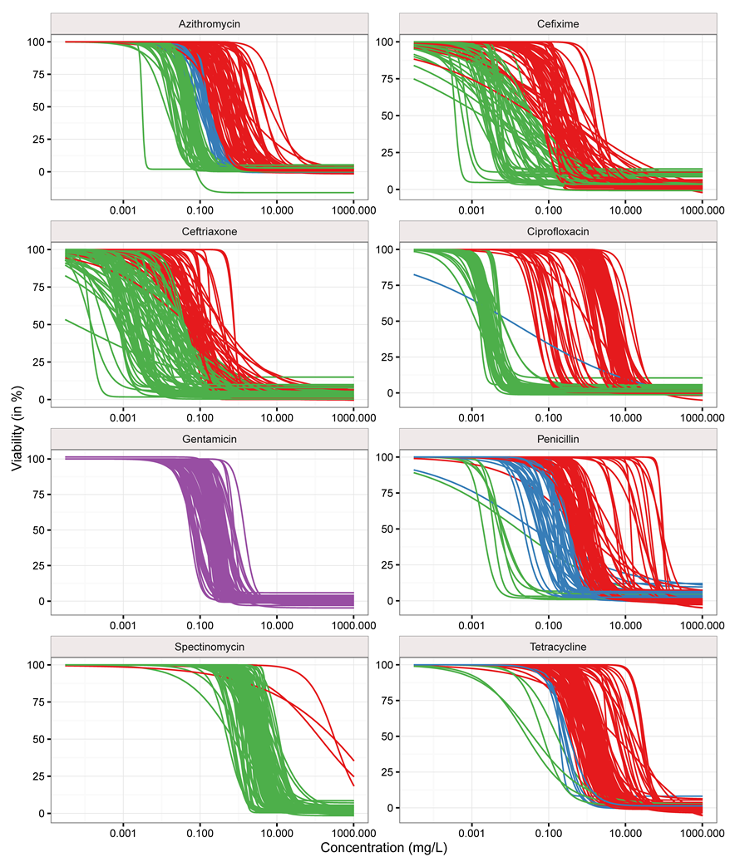

**Figure 1. Potency shift of antimicrobials across different strains.** Dose response curves for all strains and antimicrobials (without samples above limit of detection). Strains that were classified as susceptible according to EUCAST 2016 criteria were coloured in green, intermediary resistant strains in blue and resistant strains in blue. No EUCAST criteria are defined for gentamicin (purple). The gradual shift of the potencies (EC50) towards higher concentrations can be observed for all antimicrobials.

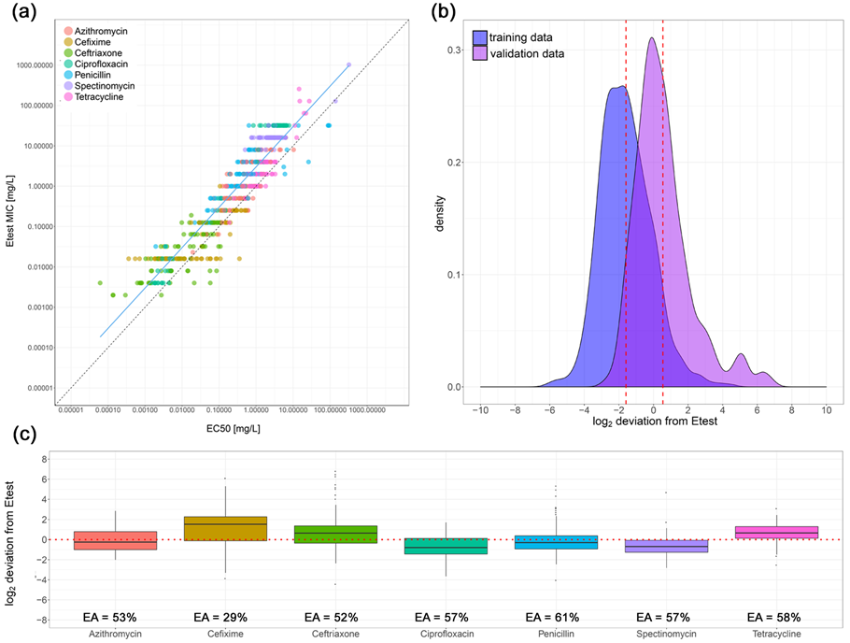

**Figure 1. Correlation and deviations between the Etest and predicted MICs.** (A) The correlation of Etest MIC and EC50 for the dataset used for developing the regression model (84 blinded strains examined) is shown for log-log transformed values. The Pearson's correlation coefficient for the linear regression was 0.83. Slope and intercept for a perfect correlation (1) was drawn as dashed black line for comparison. (B) The kernel distribution of the values for these 84 strains is drawn in blue (median -1.8). The kernel distribution of the MICs predicted with the slope and intercept of the 84 strains is highlighted in purple (median 0.11). (C) Deviations of predicted MICs (124 clinical strains examined) from Etest MIC are shown for seven antimicrobials. The boxplots show the median and 25%-75% quartiles. The whiskers span the range from the bottom 5% to the highest 95% of the data. The essential agreement (EA) defined as less than ±1 doubling dilution from Etest for each antimicrobial is written below the boxplots.

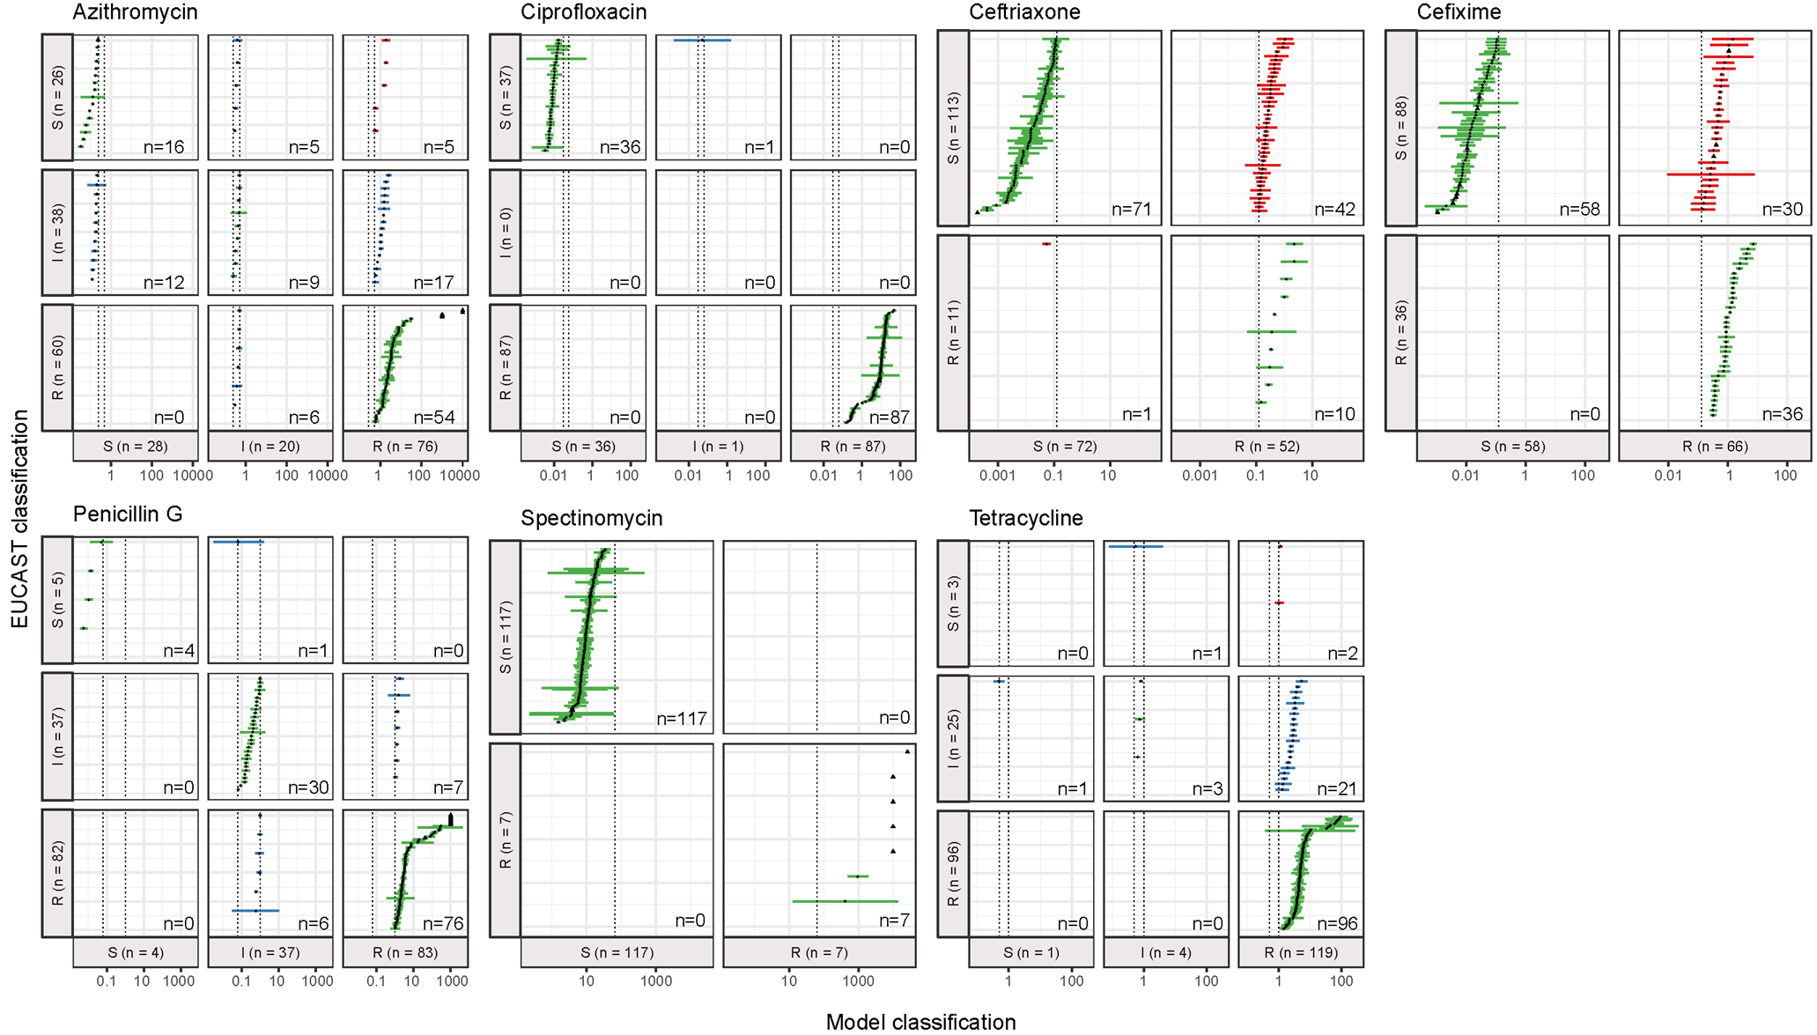

**Figure 2. Contingency table with categorical errors of model predicted MICs**. Etest MIC data were classified into the categories resistant (R), susceptible (S) and intermediate (I) according to the EUCAST 2016 criteria.30 The cutoff values (mg/L) are shown as dashed black lines. Predicted MIC values are shown as point estimate with 95% confidence interval. Correctly classified strains are depicted as green. Major errors (S to R) and very major errors (R to S) are shown in red. Minor errors resulting from misclassifications of intermediate strains are drawn in blue. Data below or above limit of detection were not included. Gentamicin and Spectinomycin were excluded from this analysis.